**Open DVWA and choose security mode:**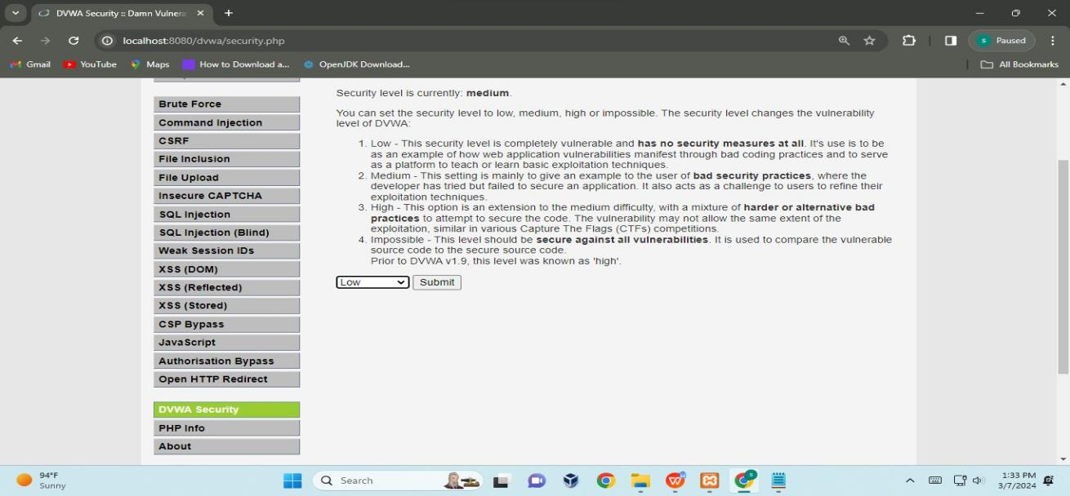

**Click on XSS stored -- fill Name(Test 1)-- add script tag in message.**

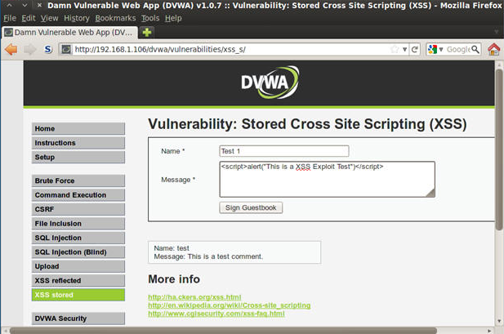

**Click on sign GuestBook.**

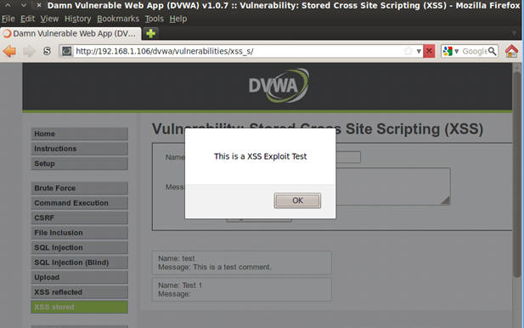

**Cross-Site Scripting Attack using testphp.vulnweb.com**

**Open website go to the inspect copy the input filed end tag paste into in name section and add our script.**

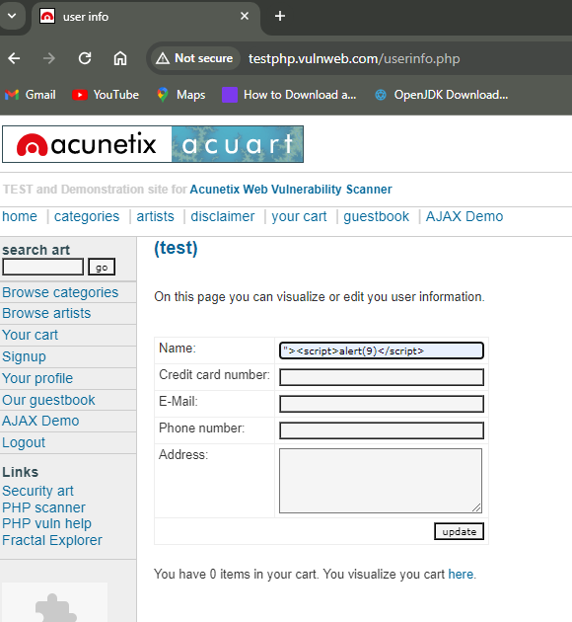

**Whenever we click on update it will give us alert message.** 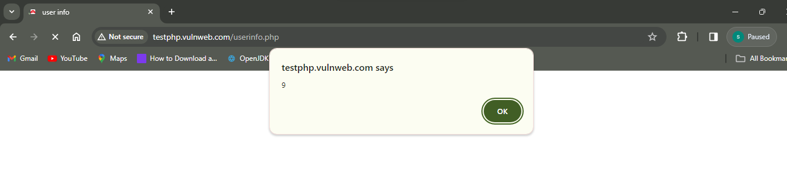

**We can add html tag also here I can use the h1 tag and give name**

**In this case when we click on the update button it will give me the test**

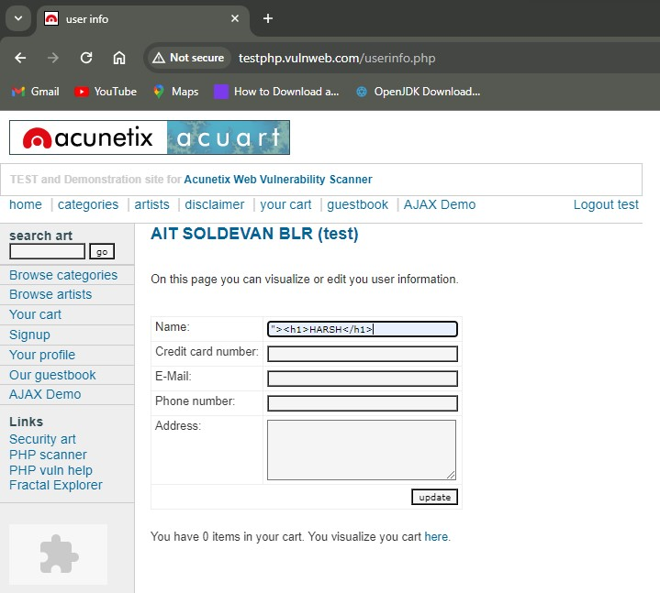

**After click on update button**

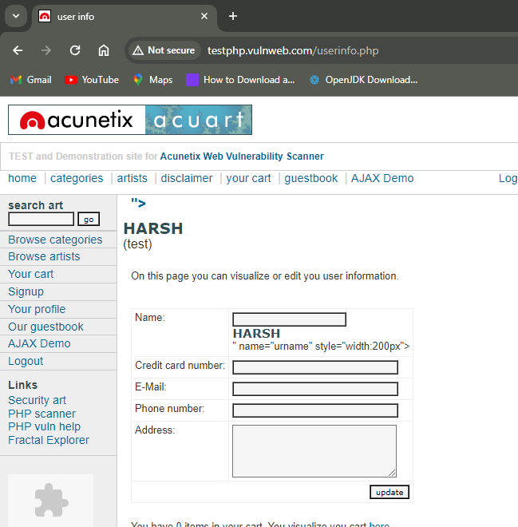

**We can open another window in another website using iframe.  
so here we can open our college website in testphp.vulnweb.com**

**Within the iframe tag we are give to the path of our college website using src attributes.**

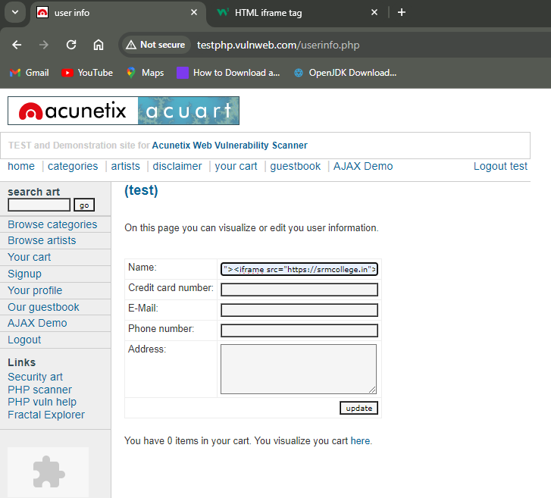

**Now we can see in url open testphp.vulnweb.com website but with in that website we can seen our college website**

